**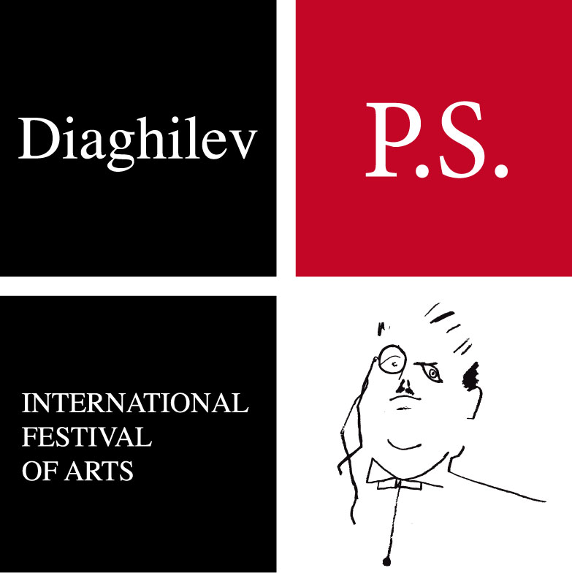**

**DIAGHILEV. P.S. 2015**

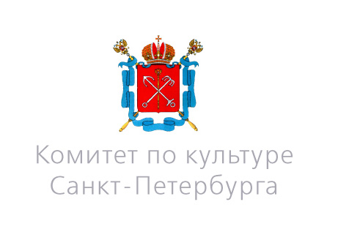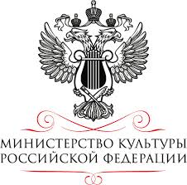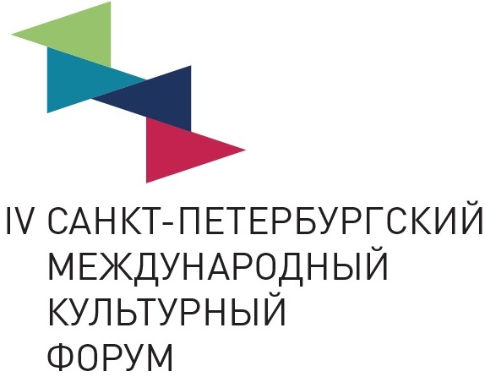

***With the support of the Ministry of Culture,***

***The Committee for Culture of St. Petersburg.***

**Under the auspices of*the IV*St*.*Petersburg International Cultural Forum**

**The 6th** **‘DIAGHILEV. P.S.’ Festival will take place in Saint-Petersburg from 15th to 24th November 2015.**

“*Torobaka”* is a powerfully gripping male duet for its two creators: **Israel Galvan,** one of the leading choreographers of contemporary flamenco, and **Akram Khan,** the celebrated British choreographer and unequalled exponent of the classical Indian Kathak style. Both these masters are known for their innovative choreography and for the exquisite refinement of their dancing technique. Both are also the recipients of many awards and are among the most established and respected artists in the world of dance.

Their collaboration in “*Torobaka*”, however, feels as much like a duel as it does a conventional duet. This is perhaps because Flamenco and Kathak are each extraordinarily vivid dance forms which stem from the depths of centuries-old tradition - in each style every movement is imbued with associations full of meaning and imagery. “*Torobaka*” therefore comes to embody both a dialogue and an exchange of ideas: even the name of the performance derives from the connection of two words, emblematic of animals sacred to the two nations involved: the bull (*toro*) and the cow (*baka*). In combining them, “*Torobaka”* comes to represent the art of dance as a universal language, spoken by different ethnic cultures but fused into one.

**15 November, 19.00, Tovstonogov Bolshoi Drama Theatre**

**Running time: 1 hour 15 minutes**

**The performance has no interval**

After the performance on the **15th November**, a press conference will be held in the auditorium of the BDT to outline the programme of DIAGHILEV. P.S. 2015. Major speakers will be the Art Director of the Festival, Natalya Metelitza, together with the choreographers Akram Khan and Israel Galván.

**15 November, after performance, Tovstonogov Bolshoi Drama Theatre**

On **16th & 17th November,** professionals - as well as all those interested in unlocking the secrets of our namesake, the great impresario Diaghilev - will meet under the aegis of the International Scientific Conference "*In Diaghilev’s Circle: Patrons*". This Conference will start a new annual cycle of dialogues under the umbrella title "*In Diaghilev’s Circle* ", which will aim to review a personality or a phenomenon that in some way came within the Impresario’s scope of activities. The essential parts of this year’s conference will be a **round table discussion** and a **master-class** by the choreographer Akram Khan.

**16 November, 11.00 – 18.00, Museum of Theatre and Music**

**16 November, 11.00 – 13.00, Boris Eifman Dance Academy – master-class**

**17 November, 11.00, Hotel Indigo St Petersburg-Tchaikovskogo – round table discussion**

**Moderator: Sergey Nikolaevich, Chief Editor of *the Snob Magazine***

On 16th of November the Festival, the New Stage of the Alexandrinsky Theater and the Institut français of Russia will present the screening of the documentary by the French director **Olivier Assayas** dedicated to **Angelin Preljocaj**. The film features the choreographer’s work on a play by the German composer **Karlheinz Stockhausen** and his conversations with the latter. A discussion with the participation of Angelin Preljocaj will be held after the screening.

* **16 November, 18.30, The New Stage of the Alexandrinsky Theater  
  Free admission**

On 17th of November DIAGHILEV. P.S. is proud to present a Gala ballet evening at the Alexandrinsky Theatre, in honor of the distinguished choreographer **Angelin Preljocaj** and the 30th anniversary of his company *Le Ballet Preljocaj.* It will be performed by *Le Ballet Preljocaj* itself, together with soloists from the Paris Opera Ballet, the Ballet of the Croatian National Theatre in Zagreb and the Berlin Opera Ballet.

At the end of the performance DIAGHILEV.P.S.’s annual honorary award ceremony "*Etonne moi!"* will take place.

**17 November, 19.00, Alexandrinsky Theatre**

**Running time: 1 hour 40 minutes**

**The performance has one interval**

18th November sees the opening of the Festival’s major exhibition: "*Silver and Gold of the Queen of Spades*". This takes place with the cooperation of the State Hermitage Museum, the Peterhof State Museum-Reserve and the Festival’s long-standing partner, the Museum of Theatre and Music.

The exhibition will reveal the captivating life history of the Princess Natalia Petrovna Galitzine (1744-1837) - the model for the fateful Countess in Alexander Pushkin's "The Queen of Spades" - and investigate how both opera and ballet have treated this masterpiece.

The Festival dedicates the exhibition to the memory of **Pyotr Ilych Tchaikovsky** in celebration of the 175th anniversary of his birth.

**18 November, 16.30 – media preview, opening (by invitation only)**

**Open to public: 19 November 2015 - 14 February 2016**

**Sheremetev Palace**

On the 18th of November, a meeting with Theodore Currentzis will take place under the frames of the “Agenda” cycle on the New Stage of the Alexandrinsky Theater.The conductor will present an overview of key processes, problems, ideas outlining the present status of the sphere of theater and music.

**18 November, 21.00, the New Stage of the Alexandrinsky Theater**

After the tremendous success of the Perm Academic Opera and Ballet Theater, during its guest appearance at last season’s Festival, this year’s programme presents a further performance by the orchestra and soloists of its ensemble **Music Aeterna**. They will give a concert performance of Mozart's opera "*Don Giovanni*" in the Grand Hall of St Petersburg Academic Philharmonia. **Music Aeterna’**s conductor, **Teodor Currentzis**, has gained an international reputation as one of the most fascinating interpreters of Mozart’s music and is a several-times winner of the prestigious ‘Golden Mask award.

**19 November, 19.30, Grand Hall of St Petersburg Academic Philharmonia**

**Running time: 3 hours 20 minutes**

**The performance has one interval**

On 20th November DIAGHILEV. P.S. will introduce the **Moreno Gistain Piano Duo** from Spain. The repertoire of the duo, who are brothers, often includes the works of composers who wrote for Diaghilev’s *Ballets Russes,* and delicately applies new performance techniques in presenting them. Their concert programme *«Ballets Russes». Spanish Motives,* for two pianos and four hands, will include compositions by Glinka, Rimsky-Korsakov, Glazunov, Manuel de Falla and Gabriel Fauré.clear

**20 November, 19.00, St Petersburg Academic Capella**

**Running time: 1 hour 20 minutes**

**The performance has one interval**

On 21st November, a photo exhibition **“*Images of La bayadère***”, by French photographer **Eugenia Grandchamp des Raux,** will open in the halls of the Sheremetev Palace. The exhibition zeroes in on impressions of the 1992 production of *La bayadère* which embodied Rudolf Nureyev’s last choreographic work for the stage of the Paris Opera. The production is still admired and successful today. In recording it, Grandchamp’s work borders on abstraction and conveys the sensation of dance movement in a way visible only through the camera lens – movement imperceptible to the unaided human eye alone.

**21 November, 15.00 – media preview, opening (by invitation only)**

**Open to public: 22 November 2015 – 24 January 2016**

**Sheremetev Palace**

On 22nd November, in honor of the 230th anniversary of the Hermitage Theatre, a special concert entitled “***Hits of the Imperial Stage****”* will be performed on its uniquely historic boards. Prepare for a ‘musical excursion’ through the repertoire of this renowned theater, traversing a course through the more than two centuries of its history.

**22 November, 19.00, Hermitage Theatre (by invitation only)**

On 23rd November an exhibition of **p*aintings and graphics by Sergey Sudeykin*** will open at St Petersburg’s KGallery. Since the October Revolution Russia has not seen a single one-man exhibition of this important artist, whose work revealed him in his lifetime as a master of fantasy, burlesque and the pastoral. Over the last years, in his homeland there has been growing an interest in Sudeikin’s heritage. Private collectors have also searched out his posters and sketches for ballets, operas and plays. His inimitable style is visible in them all. Among his greatest admirers were the prominent London collectors, Nina and Nikita Lobanov-Rostovsky, and the legendary dancer Mikhail Baryshnikov. For this exhibition Sudeikin’s works acquired from these collections will be presented by their current owners, among them is the Museum of Theatre and Music. The exhibition in KGallery will display more than fifty artworks of museum-quality, from both public and private collections.

**23 November, 19.00** – **media preview, opening (by invitation only)**

**Open to public: 24 November 2015 - 14 December 2015**

**KGallery**

For the festival’s *grand finale*, the **Martha Graham Dance Company** will present a selection its works for the first time in Russia. The programme will consist of two ballets by the company’s founder and fountainhead of American modern dance (*Chronicle* / *Diversion of Angels*), in tandem with the recent bravura *Lamentation Variations,* which boldly invites the responses of contemporary choreographers to Graham’s agonized solo in the original ballet. The programme also includes a haunting meditation on the myth of Narcissus, *Echo,* by Graham’s follower, the Greek contemporary choreographer Andonis Foniadakis. The Martha Graham Dance Companycontinues to enshrine the doctrines of its creator, revealing the essence of man in dance – “the language of the soul."

**24 November, 19.00, Alexandrinsky Theatre**

**Running time: 2 hours**

**The performance has one interval**

Further information about the DIAGHILEV. P.S. Festival: www.diaghilev-ps.ru

Programme of the DIAGHILEV. P.S. Festival 2015: http://www.diaghilev-ps.ru/en/dps\_prg.html

Images of the *Torobaka;* the *Le Ballet Preljocaj;* the opera *Don Giovanni;* the *Moreno Gistain Piano Duo;* the exhibitions *Silver and Gold of the Queen of Spades* and *Images of La Bayadère*; *the Sergey Sudeykin’s* exhibition and *Martha Graham Dance Company’s ballets* can be found via this link. Please do not forget to credit the copyright. [**https://www.dropbox.com/sh/qu4f4o9yw7cie6f/AADZHUbpvtJLN49KZC9lSmxoa?dl=0**](https://www.dropbox.com/sh/qu4f4o9yw7cie6f/AADZHUbpvtJLN49KZC9lSmxoa?dl=0)

For more background information on accreditation for the festival events and requests for interviews please contact us:

Festival PR director: Natalia Plekhanova:

+7 921 9189420 n.plekhanova@principe-media.ru

Festival artistic director: Natalia Metelitza:

+7 812 3101029 info@theatremuseum.ru

Festival programme director: Alexandra Starkman:

+7 812 3145345 [art@theatremuseum.ru](mailto:art@theatremuseum.ru)

**Partners and sponsors:**



Hennessyfounsmall

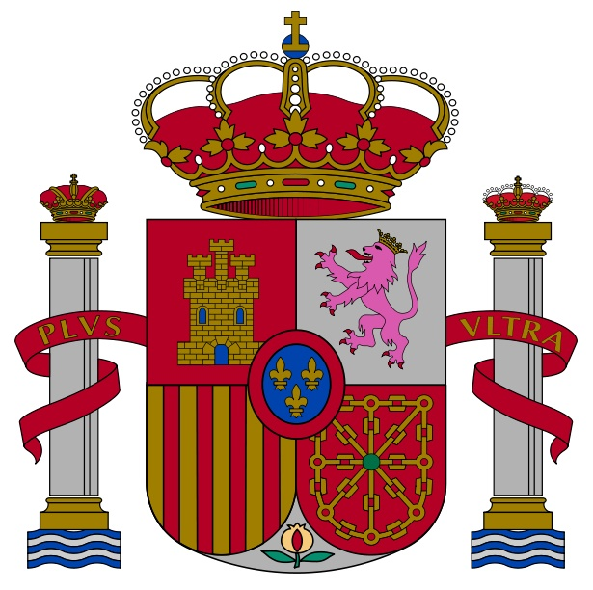

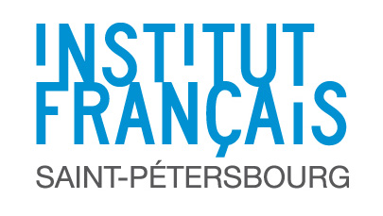**Delzell Foundation**



**U.S. Consulate General Consulate General of Spain**

**in St. Petersburg in St. Petersburg**

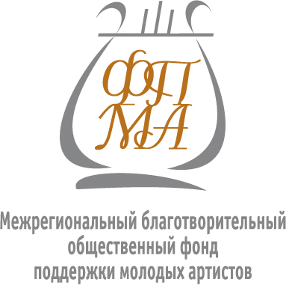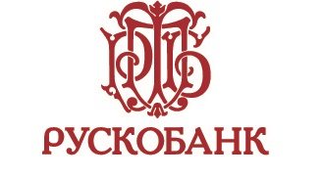**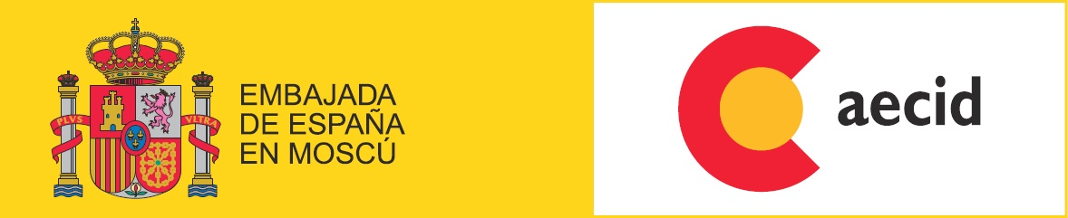**

**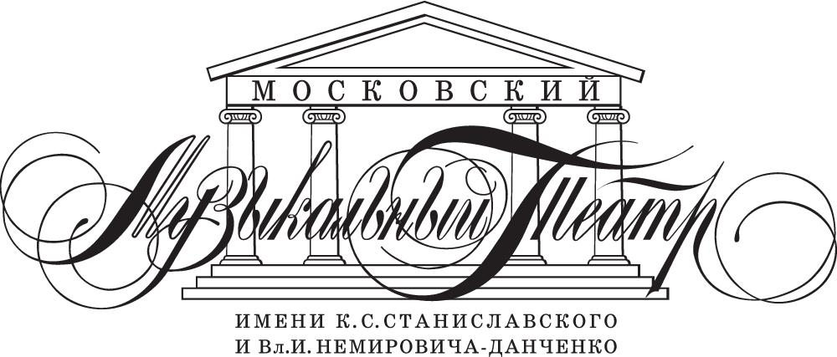**



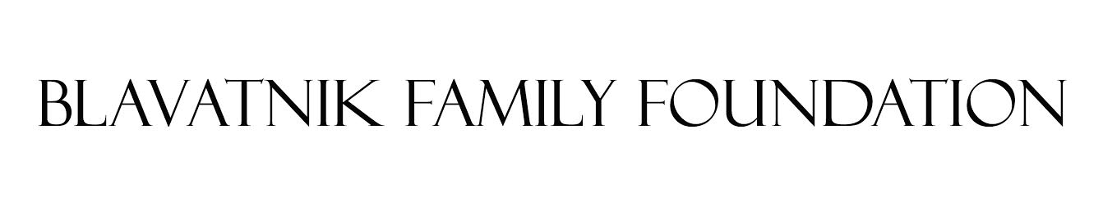

**With support: Mrs. Bettina von Siemens**

**simple_waters**

**Official water supplier:**

**Informative partners:**

AN Logotype_Cover1



